 **Methods 11 Test 7 2018**

**Expontenital & Differentiation**

**Total Marks: 59 Time Allowed: 55 minutes**

**Name: _______________________**

**SECTION A – Resource Free**

**25 minutes – 30 marks**

**ALL** working must be shown for full marks.

**1.** **[4, 4 = 8 marks]**

Solve the following **exactly**.

a) $8^{x+1}= \frac{4}{{16}^{x}}$ b) $3^{x-2}= \frac{\sqrt[3]{3}}{9^{x}}$

**2. [2, 2, 2 = 6 marks]**

State the derivative of each of the following:

a) ${2x}^{3}- x+1$ b) $(x-1)(x+2)$ b) $\frac{{5x}^{3}-3x^{5}}{{3x}^{2}}$

**3. [2 marks]**

Use an appropriate derivate to evaluate $\lim_{h→0}{{\left(\frac{\sqrt{2\left(x+h\right)}- \sqrt{2x}}{h}\right)}^{}}$

**4.** **[3, 3 = 6 marks]**

State the equation of the tangent line for each of the following curves at the given point.

a) ${y= 3x}^{4}+x, (1, 4)$

b) $y=2x\left(1-x\right), (-2, -12)$

**5.** **[8 marks]**

Given that $y= {ax}^{3}+ {bx}^{ 2}+2$ has a tangent with equation $y= -4x+5$ at the point where $x=1,$ find *a* , and *b.*

**Methods 11 Test 7 2018**

**Expontential & Differential**

**Total Marks: 59 Time Allowed: 55 minutes**

**Name: _______________________**

**SECTION B – Calculators Allowed**  **30 minutes – 29 marks**

**6.** **[1, 1, 2, 2 = 6 marks]**

The function f is such that $f\left(x\right)=1-x+ {2x}^{2}- x^{3}$

a) Determine f(2) b) Determine f’ (2)

c) Determine *x* when f’(*x*) = 0 d) Determinethe coordinates of any point on the function f where the gradient is -1.

**7.** **[3 marks]**

Use first principles to determine the derivative of $y= {5x}^{2}$.

**8.** **[1, 2, 3, 1, 1, 1, 1, 1, 2 = 13 marks]**

The population, P, of a country town in the South-West of WA may be modelled by the equation

$P\left(t\right)=400({1.15)}^{t},$

where *t* is the number of years from 1st January 2003 to the 1st January 2015.

a) What is the population of this town on 1st January 2003?

b) Is the population increasing or decreasing? Justify your answer.

c) Complete the following table:

|  |  |  |  |  |  |  |  |
| --- | --- | --- | --- | --- | --- | --- | --- |
| Year | Jan ‘03 | Jan ‘04 | Jan ‘05 | Jan ‘06 | Jan ‘07 | Jan ‘08 | Jan ‘09 |
| Population |  |  |  |  |  |  |  |

d) On the given axes sketch a graph to show the population growth until at least January 2017.

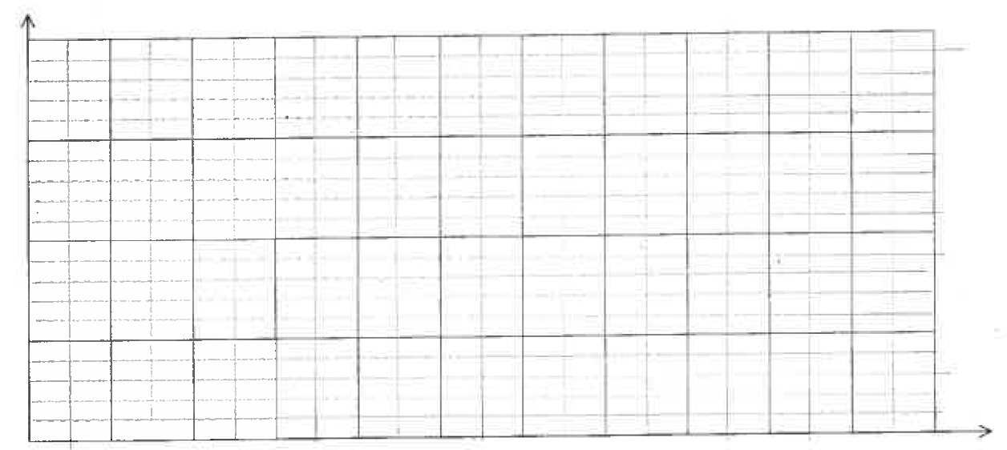

e) Justify that the population of this town is increasing using your graph.

f) Show how to use your graph to estimate when the population of this town doubles.

g) Show how use your graph to estimate the population of this town in Jan 2015.

h) Use your calculator to refine the solution for g) above to the nearest ten.

i) Examine your graph, compare and comment on the rate at which the population is increasing on 1st January 2005 and 1st January 2015.

**9.** **[1, 1, 2, 2, 1 = 7 marks]**

Soup is heated in the microwave, then removed and allowed to cool. Its temperature *T,* in $℃$, *x* minutes after being removed, is given by the formula: $T=140 {(0.85)}^{x}$

a) What was the temperature of the soup when it was taken from the microwave?

b) At what % rate is the temperature decreasing?

c) Predict the temperature of the soup after 5 minutes.

d) Soup is drinkable at a temperature of 20° C. Determine, to the nearest 0.1 minute, when this will happen.

e) Another food item is place in the microwave, heated, and left to cool. It cools at a fixed % rate, until its temperature eventually remains relatively constant at *k $℃.$* Comment on the value of *k*.